**RandomForestClassifier**



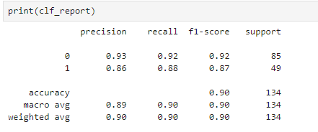

To calculate precision, recall, F1-score, accuracy, macro average, and weighted average:

* **Precision for class 0 (P0)**: TPo\TPo+FPo
* **Recall for class 0 (R0)**: TPo\TPo+FNo

• **F1-score for class 0 (F1_0)**:2*Po*Ro\Po+Ro

• Precision **for class 1 (P1)**:TP1\Tp1+FP1

• Recall **for class 1 (R1)**: TP1\TP1+FN1

• F1**-score for class 1 (F1_1)**: 2×P1×R1\P1+R1

• Accuracy: TPo+TP1\Total

• Macro **average**: The average of precision, recall, and F1-score for both classes.

• Weighted **average**: The weighted average of precision, recall, and F1-score for both classes, considering the support (number of true instances for each class).

Given the confusion matrix:

Confusion matrix= 78 7

6 43

Where:

* TP0=78
* FP0=7
* FN0=6
* TP1=43

Let's compute these metrics:

1. Precision class 0:Po=78\(78+7)=78\85=0.918
2. Recall class 0=Ro=78\(78+6)=78\84=0.929
3. F1 Score class0=F1o=2*(0.918*0.929)\(0.918*0.929)=0.923
4. Precision class 1=P1=43\(43+6)=0.878
5. Recall class1=R1=43\(43+7)=0.86
6. F1 SCORE Class 1=F1_1=2*(0.878*0.86)\(0.878+0.86)=0.868
7. Accuracy=(78+43)\134=0.904

**Macro average**:

1. Precision: 0.918+0.878\2=0.898
2. Recall: 0.929+0.86\2=0.895
3. F1-score: 0.923+0.868\2=0.896

**Weighted average**:

* Support: 85 (class 0) and 49 (class 1)
* Weighted precision: 85×0.918+49×0.878\134=0.902
* Weighted recall: 85×0.929+49×0.86\134=0.897
* Weighted F1-score: 85×0.923+49×0.868\134=0.899

Here is a summary:

* **Class 0**:
  + Precision: 0.918
  + Recall: 0.929
  + F1-score: 0.923
* **Class 1**:
  + Precision: 0.878
  + Recall: 0.86
  + F1-score: 0.868
* **Overall**:
  + Accuracy: 0.904
  + Macro average:
    - Precision: 0.898
    - Recall: 0.895
    - F1-score: 0.896
  + Weighted average:
    - Precision: 0.902
    - Recall: 0.897
    - F1-score: 0.899